Assignment 4
30 Marks
Deadline: May 8, 2026 11:59 PM (Friday)

Question 01
Suppose you have a single instruction;

Add X21, X22, X23

Register read = 20s
Instruction Fetch = 20s
Memory Operation = 40s
Register write = 20s
ALU Operation = 40s

Suppose you have a pipelined setup and a single cycle setup,
Which one will run the instruction faster? [5]

Question 02
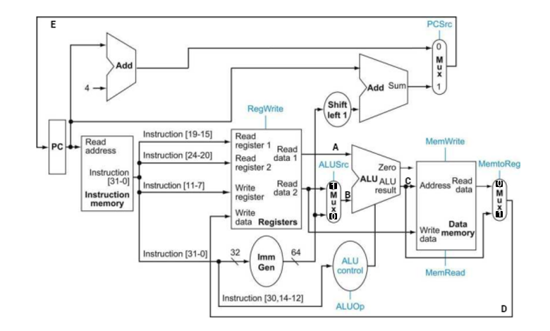
Write the control signals for the following instruction:
Ld X5, 10(X21);

i. ALU Src;
ii. RegWrite;
iii. MemRead;
iv. MemWrite;
v. MemtoReg. [5]

Question 03
Draw a simplified datapath with control unit which can execute the following instruction,
i) BLT X9, X14, L2

Question 04
Why do we keep instruction and data memory separate? [5]

Question 05

Instruction
SD X22, 12(X21)
Add X21, X22, X23
LD X23, 12(X21)
Sub X21, X21, X23
BEQ X21, X22, L1
LD X22, 0(X21)

Will any data hazards occur during the execution of this instruction set? If so, then mitigate the hazard using stall + forwarding + code scheduling techniques where applicable and calculate average CPI. [10]

